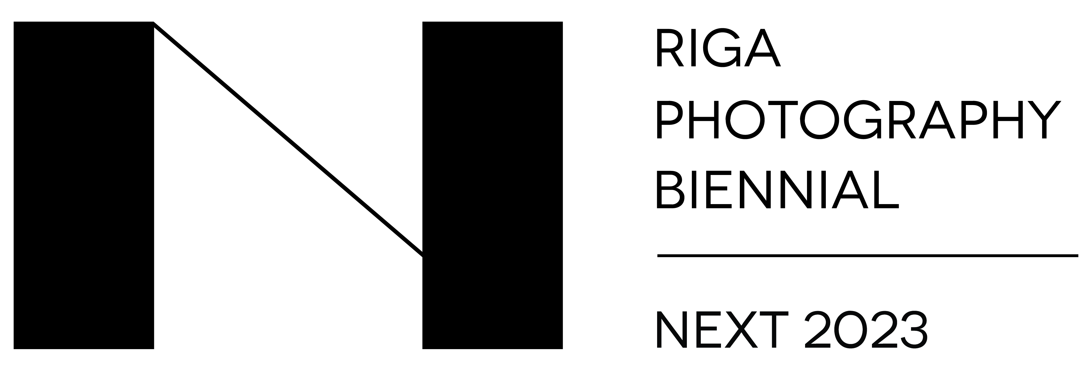

An open call for an award for young Baltic photo artists has been announced

Riga Photography Biennial – NEXT 2023 and ISSP Gallery announces an open call for the “Seeking the Latest in Photography!” Award 2023

Until 2nd October 2022, young artists from Latvia, Lithuania and Estonia are invited to submit their work for the Riga Photography Biennial – NEXT 2023 Award “Seeking the Latest in Photography!”. The winner of the award will be chosen by and international jury and will have an opportunity to hold a solo exhibition at the ISSP Gallery within the framework of the Riga Photography Biennial – NEXT 2023 (RPB – NEXT 2023) program held in May, 2023, where the awarding of other laureates will also take place. The competition participants will be receiving special prizes from “VV Foundation” and the Lithuanian independent publishing initiative “NoRoutine Books” as well.
The award "Seeking the Latest in Photography!" is an award founded by the Riga Photography Biennial - an international contemporary art event focusing on the analysis of visual culture and artistic representation. Every other year, the festival holds the programme NEXT that focuses on young and promising artists from the Baltics, Nordic countries and Europe who are still in the early stages of their careers. The award for the young Baltic artists is presented in the framework of the RPB - NEXT programme since 2016.
The goal of the award “Seeking the Latest in Photography!” is to discover and appraise the creative efforts of young artists who demonstrate the power of the image in their works, offering an original point of view and conceptual depth reflecting our current times. The curators of RPB – NEXT are seeking portfolios of artists who stimulate discussion and offer diverse ideas. At the same time, the organizers wish to provide a public platform for young artists at the beginning of their creative journey in photography or a medium associated with it, so that they can present themselves to a wider audience.
The competition is open to emerging artists and photographers from the Baltic states – Estonia, Latvia and Lithuania – provided that the work they are entering in the competition was created within the last three years.
The winner of the prize will be determined by an international jury comprised of the founder of the "BZH Photo" festival and coordinator of the "Photo Days" event in Paris Camille Gajate (FR), art critic, historian and curator Adam Mazur (PL), artist, professor and Head of the Photography Department at the Estonian Academy of Arts Marge Monko (EE), artist and curator Paulius Petraitis (LT) and artist and teacher Ieva Epnere (LV).
Besides the main prize – an opportunity to hold a solo exhibition at the ISSP Gallery in Riga, the jury members will nominate five finalists (including the winner) who will present their work at the exhibition launch, and ten finalists who will be granted the opportunity to participate in the NEXT 2023 program portfolio review to the industry professionals free of charge. For the second time, the foundation „VV Foundation” is to choose a laureate for a 1000 euro monetary prize and an opportunity to spend a month working at their residency “PAiR” (Pāvilosta Artist in Residency) in Pāvilosta, Latvia. The founders of the independent publishing initiaive “NoRoutine Books”, Gytis Skudžinskas and Vilma Samulionyte (LT), will select one of the participants for their own award – the opportunity to publish a photo book.
The winners of the RPB 2016 award “Seeking the Latest in Photography!” were Vika Eksta (LV), Andrejs Strokins (LV) and Alissa Nirgi (EE). The 2018 winners were Diāna Tamane (LV), Taavi Suisalu (EE) and Kristīne Madjare (LV). In 2019, the award was received by Annija Muižule (LV). In 2021, Visvaldas Morkevičius (LT) became the winner, and he also received the first award presented by the “VV Foundation”. The winners of the “NoRoutine Books” award were Ieva Balode (LV) in 2016, Madara Gritāne (LV) in 2018, Reinis Lismanis (LV) in 2019 and Kristīne Krauze-Slucka in 2021.
The term ‘photography’ in the Riga Photography Biennial title is used as an all-embracing concept encompassing a mixed range of artistic image-making practices that have continued to transform the lexicon of contemporary art in the 21st century. The Riga Photography Biennial – NEXT offers visibility and provides a platform for promising young artists from the Baltics, Nordic countries and Europe and helps to announce themselves to a wider audience and context. The NEXT festival edition taking place in spring 2023 is to be the fourth edition of the RPB – NEXT programme. Read more on: www.rpbiennial.com
ISSP is a platform for contemporary photography that is based in Latvia and operates internationally. Since its establishment in 2006, ISSP has been fostering an active photography scene in Latvia, educating the young generation of artists and promoting international exchange. With the opening of the ISSP Gallery in Berga Bazārs, 13 k-3 Marijas Street, Riga, ISSP has made its mark on the cultural map as the only space in Latvia dedicated to contemporary photography. Read more on: www.issp.lv
Further information about applying: http://rpbiennial.com/open_call.html
Images attached:
- Visvaldas Morkevičius ( LT), from the series “Looking forward to meet Me”, 2020
- Visvaldas Morkevičius (LT), from the series “Looking forward to meet Me”, 2020
- Visvaldas Morkevičius (LT), from the series “Looking forward to meet Me”, 2020
- Kristīne Krauze-Slucka LV), “Vibrations of a Material Universe. Thirst of Gold”, 2021
- Kristīne Krauze-Slucka (LV), “Vibrations of a Material Universe. Thirst of Gold”, 2021
Download the images in higher resolution: https://drive.google.com/drive/folders/1_tNOwvNGi8QFGFR7jxg1o1Rxy1poH5Kw?usp=sharing

Additional information:
Amanda Boka
Riga Photography Biennial communication manager
www.rpbiennial.com
amanda.boka@rpbiennial.com
+371 26551248

